Batch: A2 Roll No.: 16010122034

Experiment / assignment / tutorial No._______

TITLE :Implementation of FIFO Page Replacement Algorithm

AIM: The FIFO algorithm uses the principle that the block in the set which has been in for the longest time will be replaced
______________________________________________________________________
Expected OUTCOME of Experiment: (Mention CO/CO’s attained here)
CO3- Learn and evaluate memory organization and cache structure
CO2- Understand the Central processing unit with addressing modes and working of control
unit in depth
_____________________________________________________________________
Books/ Journals/ Websites referred:
- Carl Hamacher, Zvonko Vranesic and Safwat Zaky, “Computer Organization”, Fifth Edition, TataMcGraw-Hill.
- William Stallings, “Computer Organization and Architecture: Designing for Performance”, Eighth Edition, Pearson.
3. Dr. M. Usha, T. S. Srikanth, “Computer System Architecture and Organization”, First Edition, Wiley-India.
---------------------------------------------------------------------------------------------------------
Pre Lab/ Prior Concepts:

T he FIFO algorithm uses the principle that the block in the set which has been in the block for the longest time is replaced. FIFO is easily implemented as a round robin or criteria buffer technique. The data structure used for implementation is a queue. Assume that the number of cache pages is three. Let the request to this cache is shown alongside.

Algorithm:

1. A hit is said to be occurred when a memory location requested is already in the cache.
2. When cache is not full, the number of blocks is added.
3. When cache is full, the block is replaced which was added first
Design Steps:

- Start
- Get input as memory block to be added to cache
- Consider an element of the array
- If cache is not full, add element to the cache array
- If cache is full, check if element is already present
- If it is hit is incremented
- If not, element is added to cache removing first element (which is in first).
- Repeat step 3 to 7 for remaining elements
- Display the cache at very instance of step 8
- Print hit ratio
- End.

Example:

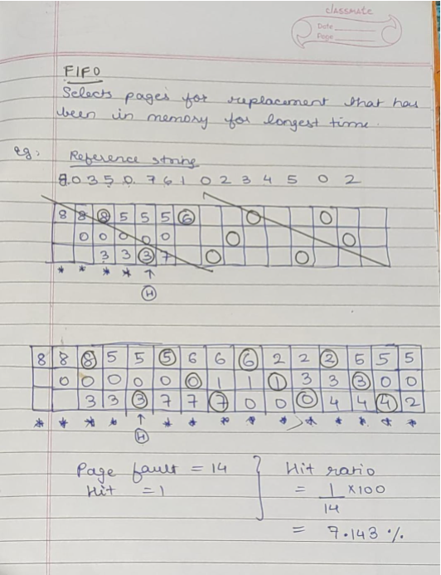

CODE:
nums = input().split()
ram = [None, None, None]
recency = [0, 1, 2]
for num in nums:
print()
if num not in ram:
print("Fault.")
index = recency.index(0)
ram[index] = num
for i in range(3):
if i == index:
recency[i] = 2
elif recency[i]:
recency[i] -= 1
else:
print("Hit.")
index = ram.index(num)
print(ram)

OUTPUT:
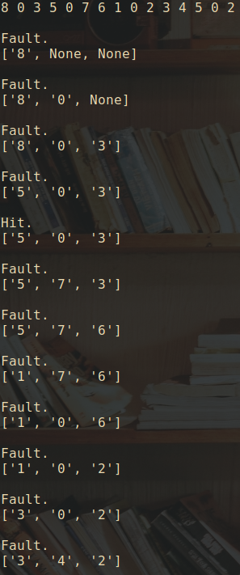
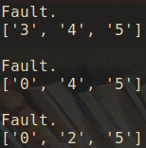

Post Lab Descriptive Questions
1. What is meant by memory interleaving?
Memory Interleaving is less or More an Abstraction technique. Though its a bit different from Abstraction. It is a Technique which divides memory into a number of modules such that Successive words in the address space are placed in the Different module.
Let us assume 16 Data’s to be transferred to the Four Module. Where Module 00 be Module 1, Module 01 be Module 2, Module 10 be Module 3 & Module 11 be Module 4. Also 10, 20, 30….130 is the data to be transferred.
From the figure above in Module 1, 10 [Data] is transferred then 20, 30 & finally, 40 which are the Data. That means the data are added consecutively in the Module till its max capacity.
Most significant bit (MSB) provides the Address of the Module & least significant bit (LSB) provides the address of the data in the module.
For Example, to get 90 (Data) 1000 will be provided by the processor. In this 10 will indicate that the data is in module 10 (module 3) & 00 is the address of 90 in Module 10 (module 3). So,
Module 1 Contains Data : 10, 20, 30, 40
Module 2 Contains Data : 50, 60, 70, 80
Module 3 Contains Data : 90, 100, 110, 120
Module 4 Contains Data : 130, 140, 150, 160
An interleaved memory with n banks is said to be n-way interleaved. In an interleaved memory system, there are still two banks of DRAM but logically the system seems one bank of memory that is twice as large.
In the interleaved bank representation below with 2 memory banks, the first long word of bank 0 is floowed by that of bank 1, which is followed by the second long word of bank 0, which is followed by the second long word of bank 1 and so on.
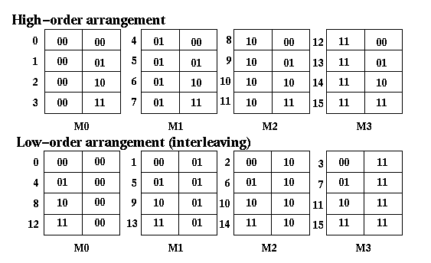
2. Explain Paging Concept?
Paging is a method of writing data to, and reading it from, secondary storage for use in primary storage, also known as main memory. Paging plays a role in memory management for a computer's OS (operating system).
In a memory management system that takes advantage of paging, the OS reads data from secondary storage in blocks called pages, all of which have identical size. The physical region of memory containing a single page is called a frame. When paging is used, a frame does not have to comprise a single physically contiguous region in secondary storage. This approach offers an advantage over earlier memory management methods, because it facilitates more efficient and faster use of storage.
Example:
- If Logical Address = 31 bit, then Logical Address Space = 231 words = 2 G words (1 G = 230)
- If Logical Address Space = 128 M words = 27 * 220 words, then Logical Address = log2 227 = 27 bits
- If Physical Address = 22 bit, then Physical Address Space = 222 words = 4 M words (1 M = 220)
- If Physical Address Space = 16 M words = 24 * 220 words, then Physical Address = log2 224 = 24 bits
The mapping from virtual to physical address is done by the memory management unit (MMU) which is a hardware device and this mapping is known as paging technique.

Conclusion
Implementation of FIFO Page Replacement Algorithm is done successfully. Implementation of FIFO Page Replacement Algorithm

Date: _____________

